WEEK—1

E-commerce Platform Search Function

1. **Understand Asymptotic Notation:**

* + Explain Big O notation and how it helps in analyzing algorithms.
  + Describe the best, average, and worst-case scenarios for search operations.

Big O notation is used to describe the efficiency of algorithms in terms of their time complexity or space complexity. It helps in comparing different algorithms based on their time complexity and input size.

Best case – Element is at beginning

Linear - O(1)

Binary - O(1)

Average case – The element must be somewhere in middle

Linear - O(n)

Binary - O(log n)

Worst case – The element may be at end

Linear - O(n)

Binary - O(log n)

**4.Analysis:**

* + Compare the time complexity of linear and binary search algorithms.
  + Discuss which algorithm is more suitable for your platform and why.

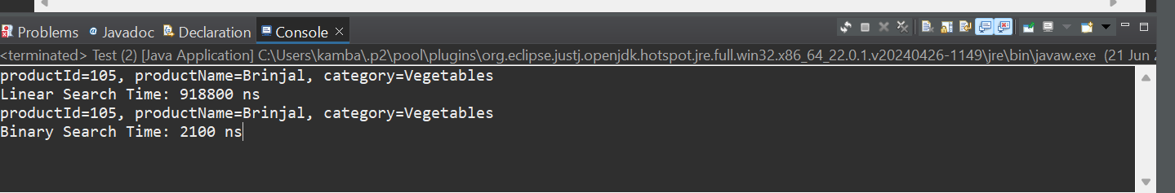

Linear search -- **918,800 nanoseconds**

Binary search -- **2,100 nanoseconds**

Binary search was **much faster** in this case.

Linear Search – suitable for small datasets and for unsorted data

Binary Search – Best for large datasets and for only sorted data

As E-Commerce Platform deals with large number of products , Binary Search is more helpful for faster retrieval.